Product Manual

Name：Bluetooth RGBW LED Bulb V1.0
Model：ZJ-MBL-RGBW V1.0
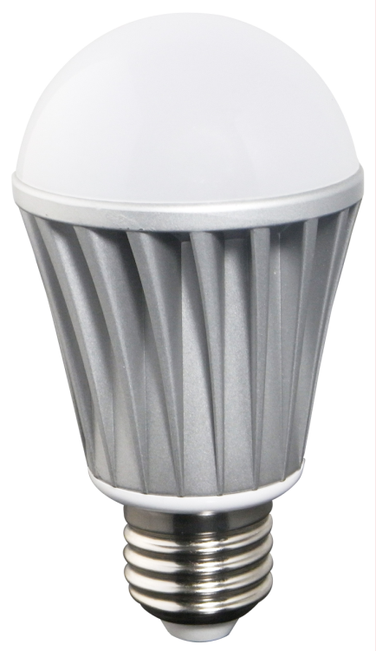

I. Product Summarize
This bulb support Bluetooth version 4.0 or above.
It can achieve remote control ,switch light,adjust brightness and color temperature.There are 16 million colors and dozens of light changing modes.In addition, it do not need additional line,conveniently installed and used.
It is a high capability and easily replaceable LED bulb.Certainly,it have other advantages,such as light source is LED,power consumption is just 20% of traditional incandescent,working life is 10 times of traditional save-power light,safe and stable.
The case adopts aluminum fins,which can let air backflow cyclically.This design resolved high-powered LED thermal problems in highest degree.Bulb is made of graced poly materials with high transmitacnce 85% or above,and luminous is uniformity.It controlled by wireless Bluetooth,furthest remoted distance catch up to 40m.It enjoys low power-consumption ,great anti-jam capacibity,high transmission speed.It can keep light memory(when restart,it will auto keep previous status before shutdown). In addition ,it will turn on in default when energized.This function avoid this situation that you cann’t turn on light when phone were lost.
It can be used widely in bedroom ,living room ,entertaining place and operating atmosphere etc.
II.Technical Parameter:
Conection Methods | Bluetooth Version 4.0
Suitable Phone OS | Any OS support Bluetooth version 4.0 or above
Software language | English
Channels | 4（RGBW）
Chips Specification | RGB：5050-1.5W*5,Warm White：2835*10
Light Luminous Flux | Red: 45-75LM,  Green: 100-150 LM  Blue: 20-50LM  Warm White:400-550LM
Wavelength | Red: 620-630nm  Green: 520-525nm  Blue: 450-460nm
White Color Temperature | 3000K-3200K
Emitting Angle | 120°
Working Voltage | AC85V-AC240V 50/60Hz
Power | RGB:<7W，Warm White:<6.5W
Power Factor | 0.6
Working Temperature | -25℃-55℃
Effective Romoted Distance | No barrier,40m ;Indoor, 20m
Bulb Material | Milk white PMMA
N.W | 94g
G.W | 110g
Waterproof | IP 25
Bulb Size | D:58.5mm  H:109mm

2. Connect Bluetooth RGBW LED Bulb
Pls connect the bulb with power supply by correct connection.Then open phone’s Bluetooth service.If your Bluetooth service is off ,Phone will antumatic pop-up a interface ”Turn On Bluetooth to Allow “Magic Light “to Connect to Accessories.Choose “Settings” first ,then “on “bluetooth .
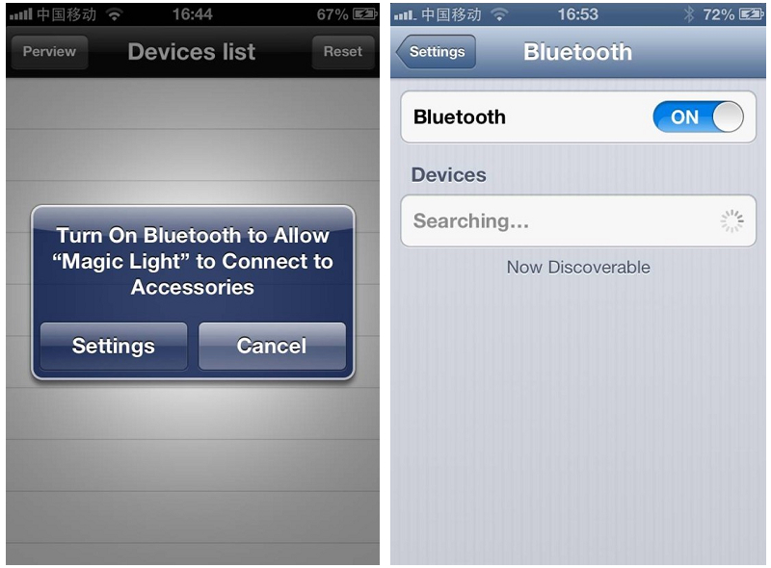

*****************************************************************************************************************************
Warranty Time:

2 years(include scond year).Any problem caused by quality,we will provide free maintenance.

Remarks:

1.Pls don’t operate it when energized.
2.Pls don’t use it in areas which are full of metal and strong electromagnetic waves.Otherwise,effective remoted distance will be shortened significantly.

Notice:

1.Thanks for using our product .Pls read our product specification manual.When you use it ,it means that you have read our manual defaultly.
2.Our company have the right of exlanation and modification of all files equipped.Sorry for that we will not give you additional notice if there were many modifications.

